Assignment-1
Dept Table:
DeptNo | Dname | Loc
10 | Accounts | Bangalore
20 | IT | Delhi
30 | Production | Chennai
40 | Sales | Hyd
50 | Admn | London
Emp Table:
EmpNo | Ename | Sal | Hire_Date | Commission | DeptNo | Mgr
1001 | Sachin | 19000 | 1-Jan-1980 | 2100 | 20 | 1003
1002 | Kapil | 15000 | 1-Jan-1970 | 2300 | 10 | 1003
1003 | Stefen | 12000 | 1-Jan-1990 | 500 | 20 | 1007
1004 | Williams | 9000 | 1-Jan-2001 | NULL | 30 | 1007
1005 | John | 5000 | 1-Jan-2005 | NULL | 30 | 1006
1006 | Dravid | 19000 | 1-Jan-1985 | 2400 | 10 | 1007
1007 | Martin | 21000 | 1-Jan-2000 | 1040 | NULL | NULL

- Select employee details of dept number 10 or 30
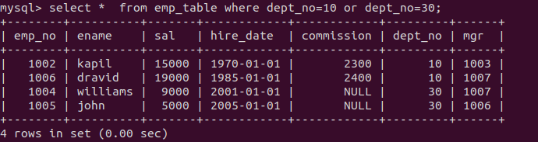

- Write a query to fetch all the dept details with more than 1 Employee.
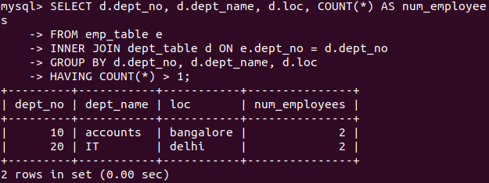
- Write a query to fetch employee details whose name starts with the letter “S”
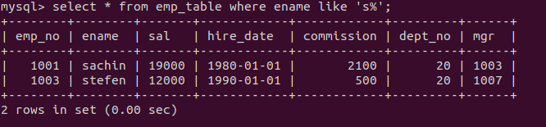
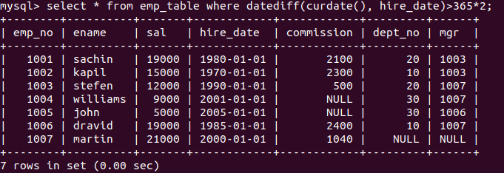
- Select Emp Details Whose experience is more than 2 years

- Write a SELECT statement to replace the char “a” with “#” in Employee Name ( Ex: Sachin as S#chin)
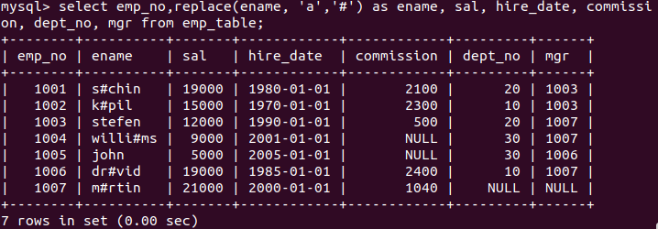
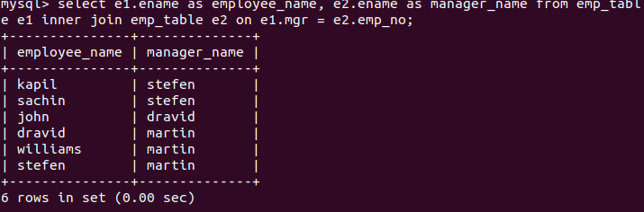
- Write a query to fetch employee name and his/her manager name.

- Fetch Dept Name , Total Salry of the Dept
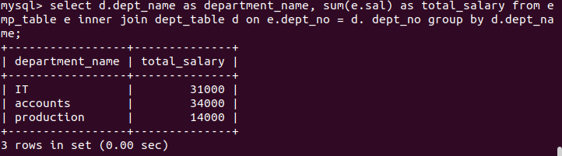
- Write a query to fetch ALL the employee details along with department name, department location, irrespective of employee existance in the department.
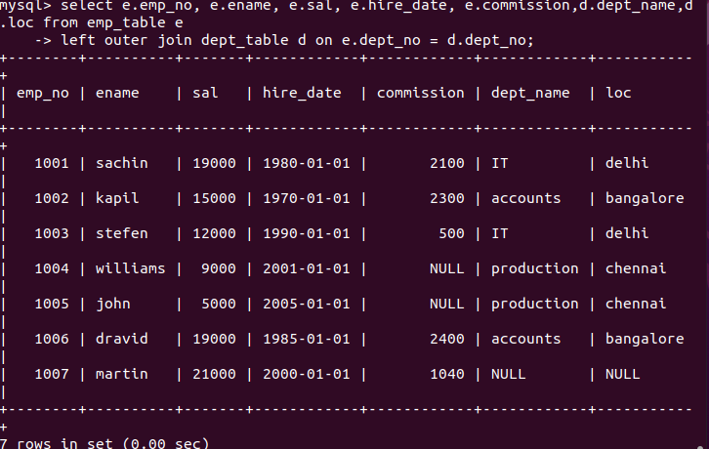
- Write an update statement to increase the employee salary by 10 %
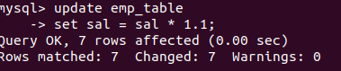
- Write a statement to delete employees belong to Chennai location.
- Get Employee Name and gross salary (sal + comission) .
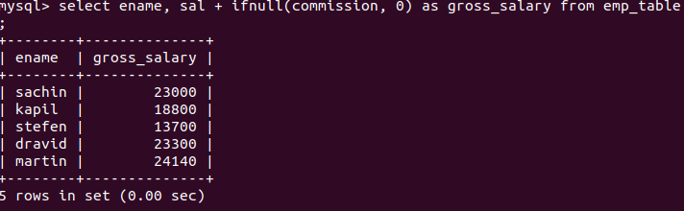
- Increase the data length of the column Ename of Emp table from 100 to 250 using ALTER statement
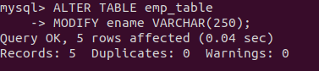
- Write query to get current datetime
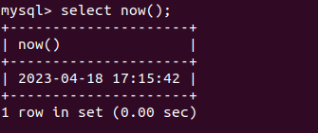
- Write a statement to create STUDENT table, with related 5 columns
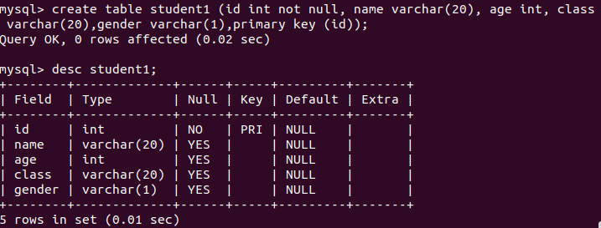
- Write a query to fetch number of employees in who is getting salary more than 10000
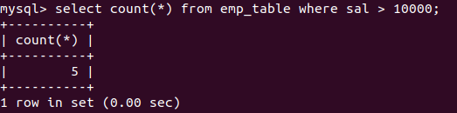
- Write a query to fetch minimum salary, maximum salary and average salary from emp table.
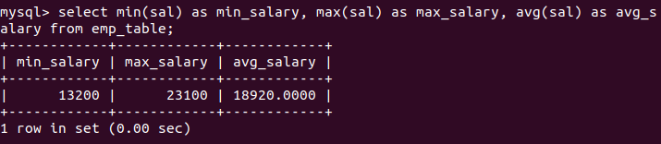
- Write a query to fetch number of employees in each location

- Write a query to display emplyee names in descending order
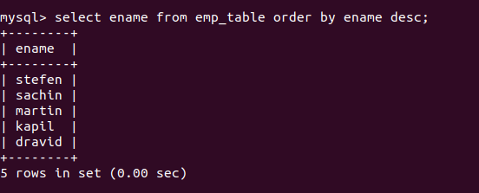
- Write a statement to create a new table(EMP_BKP) from the existing EMP table
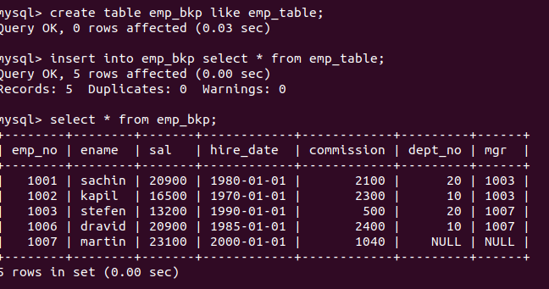
- Write a query to fetch first 3 characters from employee name appended with salary.
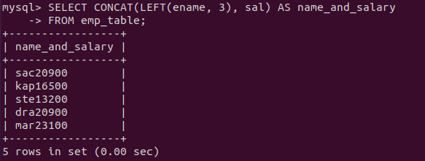
21) Get the details of the employees whose name starts with S
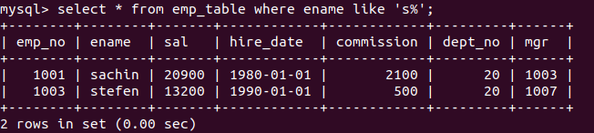
22) Get the details of the employees who works in Bangalore location
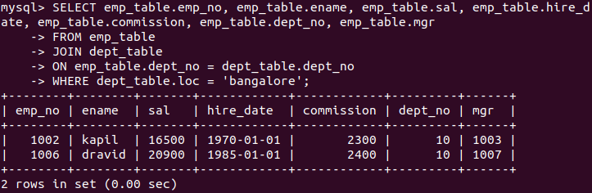
23) Write the query to get the employee details whose name started within any letter between A and K
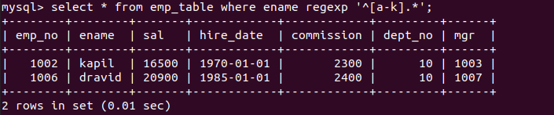
24) Write a query in SQL to display the employees whose manager name is Stefen
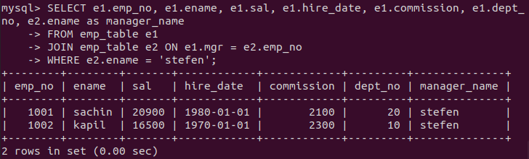
25) Write a query in SQL to list the name of the managers who is having maximum number of employees working under him
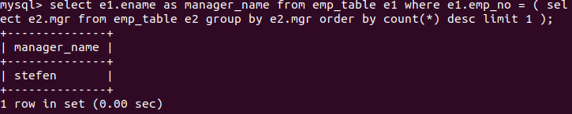
26) Write a query to display the employee details, department details and the manager details of the employee who has second highest salary
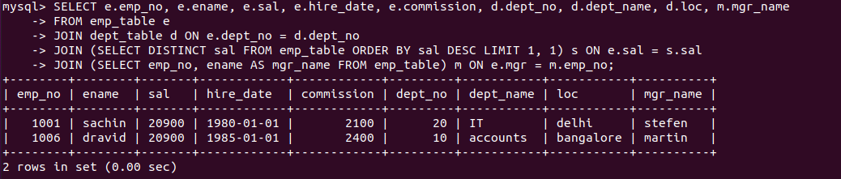
27) Write a query to list all details of all the managers
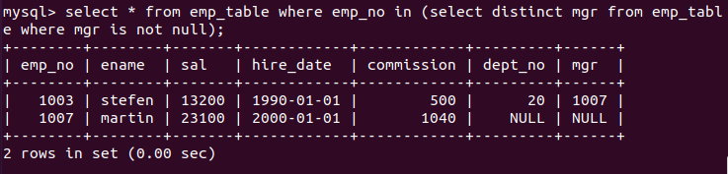
28) Write a query to list the details and total experience of all the managers
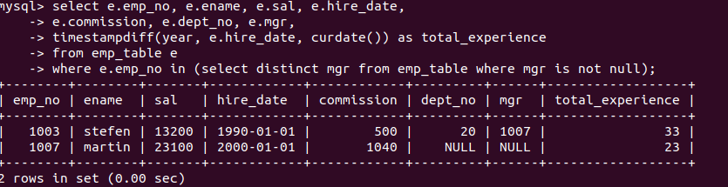
29) Write a query to list the employees who is manager and takes commission less than 1000 and works in Delhi
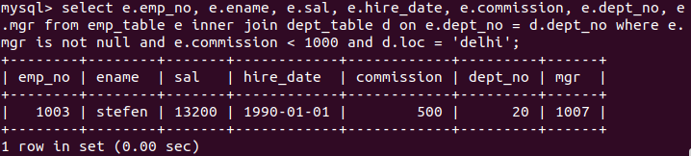
30) Write a query to display the details of employees who are senior to Martin
